**What your answer should include…**

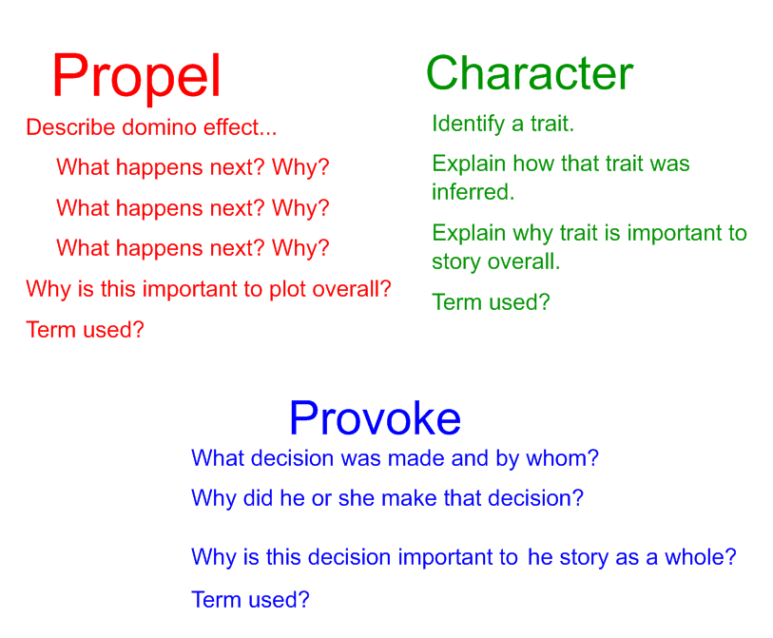

Exemplar Answers from Practice Summative on “The Adventures of Tom Sawyer”

**Dialogue to analyze--“Like it? Well I don’t see why I oughtn’t to like it. Does a boy get a chance to whitewash a fence every day?”**

PROPEL

This dialogue propels the action by making Ben want to paint the fence. So, he gives Tom his apple to do so. Tom learns, through his experience with Ben, that he can get the fence painted by taking advantage of other kids. This propels him to repeat this over and over until the fence is finished.

This series of action sets up the **rising action** in which Tom deceives kids to **resolve** his initial **conflict** of having to paint the fence. From this, the story's **theme** is derived: people naturally desire what they cannot have.

CHARACTER

The dialogue reveals that Tom is deceitful, mischievous, dishonest, and clever. His ability to quickly come up with a plan to avoid work and to persuade the other kids reveals these traits.

If not for Tom's cleverness, his initial **conflicts** of not having any "treasures" and having to paint the fence would not have been **resolved**.

PROVOKE

This dialogue provoked Ben's decision to offer to paint the fence. He even decides to give Tom his apple.

He does this because Tom made painting seem like a fun and special task.

Ben's decision is important to the story as a whole because it shows Tom that his plan will work and ultimately leads to the **climax** of getting the entire fence painted without having to work.